**i) TO FIND MAXIMUM AND MINIMUM VALUE IN ARRAY :**

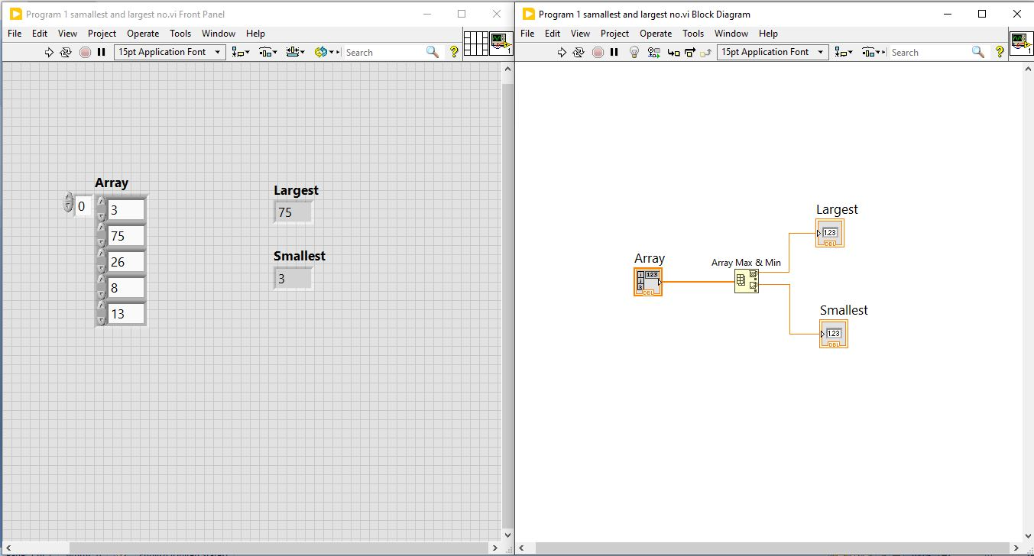

**ii) SWAP ARRAY ELEMENTS :**

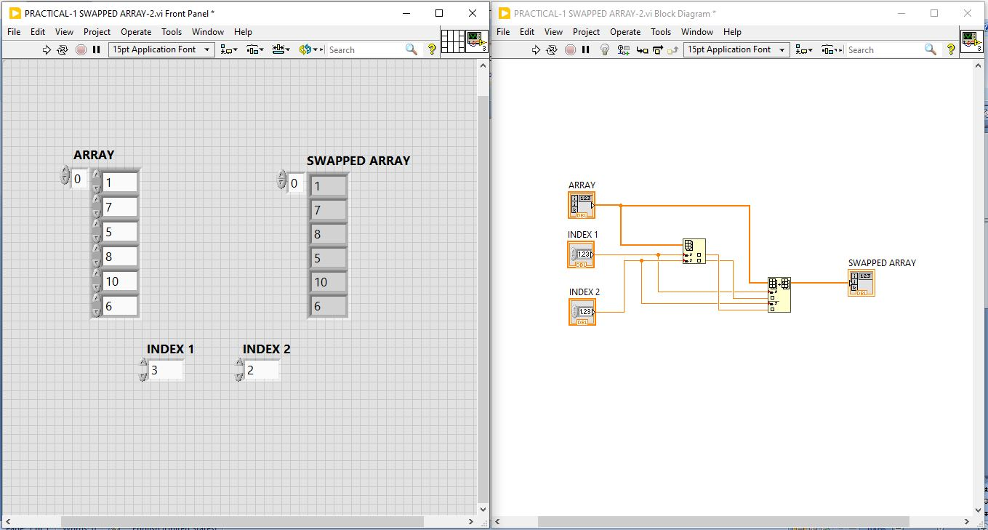

**iii) TO ARRANGING ELEMENT IN ARRAY IN A INCREASING ORDER USING BUBLE SOR**T.

